Exercise 4

- List the first and last names of all employees who draw less than or equal to $90000 and are not Programmers, Senior Programmers or Multimedia Programmers.

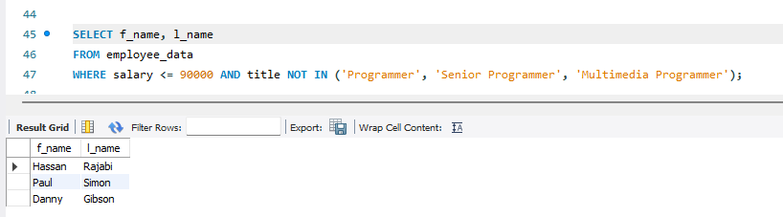

- What is displayed by the following statement?
SELECT l_name, f_name from employee_data where title NOT LIKE ‘%marketing%’ AND age < 30
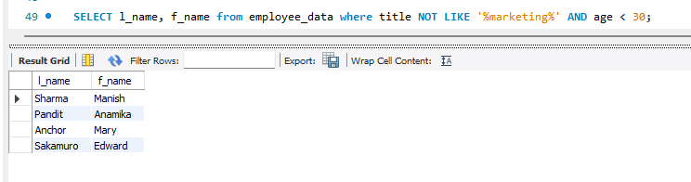

- List all ids and names of all employees between 32 and 40 years of age.
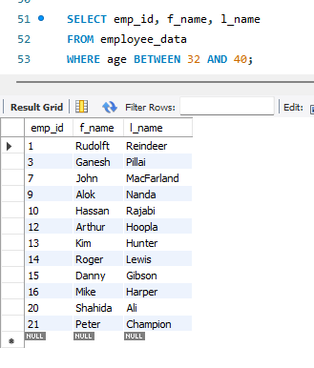
- Select names of all employees who are 32 years of age and are not programmers.
